Guidance for education institutions on Fire and life safety design and Sustainability
Draft Consultation report

Contents

Executive Summary
Chapter One: Why and how we consulted
ARB’s role
Changing context
The role of the new guidance
How we consulted
Chapter Two: Who responded
Chapter Three: What the respondents said
Introduction
Clarity of the Fire and life safety design guidance
Clarity of the Sustainability guidance
Implementation
Chapter Four: ARB’s response
Introduction
Clarity of the Fire and life safety design guidance
Clarity of the Sustainability guidance
Implementation
Chapter Five: Conclusion
Annex A: List of respondents

Executive Summary

Everybody deserves a built environment in which they can feel safe and live well, and architects are the experienced professionals who design buildings and environments. The Architects Registration Board (ARB) publishes a register of all architects in the UK. We must ensure everyone admitted to the register has the necessary skills, knowledge, experience and behaviours to practise as an architect. We currently do this by setting criteria and processes for schools of architecture, so that we can recognise their qualifications and their students can qualify as architects.
From 25 February to 23 April 2021 we consulted on new guidance on those criteria on the topics of fire and life safety, and sustainability. The guidance will be issued to institutions to help to ensure that architecture students are well trained to be able to design safe and sustainable buildings and environments. This report details the outcome of that consultation. Below we explain why and how we consulted; who responded; what they said; what changes we are making as a result of their feedback. We also explain how we will take wider feedback, for example around implantation of guidance, into account.
We received 48 responses to our consultation, including 15 submitted on behalf of organisations. We asked respondents to rate the clarity of each guidance document; 43% thought the Fire and life safety design guidance was clear and 16% thought it wasn’t clear. On the Sustainability guidance, 40% thought it was clear and 23% thought it wasn’t clear. The majority (69%) of respondents agreed that we should begin incorporating the guidance into our prescription process from September 2021. We proposed that we check progress of implementation through our annual monitoring process, and the majority (85%) of respondents agreed with our proposal.
Below are some of the key decisions we made as a result of the consultation:
- We will be more explicit about the status of this guidance by writing to institutions that deliver ARB-recognised qualifications to set out that, as supplementary guidance to the ARB General Criteria, it is a formal part of the prescription process.
- We will strengthen wording in the fire and life safety guidance to include collaboration and consultation as part of the architect’s role in the design team.
- We are currently reviewing the initial education and training of architects, and the way that we recognise qualifications so that architects can join the UK register. We will use the feedback we have received from this consultation to inform the review of ARB criteria and the importance of sustainability throughout education and training.
- We will give further clarity on how we intend to monitor the introduction of the guidance. We will require institutions to explain how they are working to implement the guidance, and then monitor progress against that plan through our existing prescription processes.
- We will give institutions time to plan how they will develop and deliver any additional course content required as a result of the guidance. Our expectation is that there is a commitment to do so within a reasonable time and that progress can be demonstrated during the annual review process.

Chapter One: Why and how we consulted

ARB’s role
  - As the professional regulator of architects, it is ARB’s statutory responsibility to ensure everyone admitted to the register has the necessary skill, knowledge, experience and behaviour to practise as an architect. To achieve this, we prescribe – meaning recognise – the qualifications and practical experience that an architect must have at the point of registration. We currently do this by setting criteria and processes for institutions of Higher Education, so that we can recognise their qualifications and their students can qualify as architects.
  - We maintain a register of those all those suitably qualified as part of our role in public protection. Anyone using an architect’s services, or a building designed by an architect, can be reassured that the design has been developed by someone who is competent.

Changing context
  - As new generations of architects study and start to practice, they need to be skilled in addressing new social and environmental challenges and opportunities. In August 2020, ARB surveyed over 4,400 architects. When asked about the issues that had become more important to their job in the last five years, the two most common issues raised by architects were safety and sustainability:
- The management of health and safety risks, including fire safety, was raised by 96% of respondents as being more or much more important;
- The climate emergency and sustainability was raised by 88%.
  - Following the tragedy of the Grenfell Tower fire in 2017, architects and other built environment professionals are increasingly aware of the importance of their work and the need to ensure buildings are safe for people to live, sleep and work in. The long-term effects of human intervention in the Earth’s climate must be addressed urgently. Architects have a significant role to play in addressing the challenges.
  - These issues are crucial to the role architects play in society, but they also go far beyond the role of architects. The Ministry for Housing, Communities and Local Government is developing new laws and policies to ensure that everyone working in the built environment understand their own responsibilities. This includes architects, contractors, building owners, inspectors, and other professionals.

The role of the new guidance
  - We have a responsibility to ensure that institutions teaching qualifications in architecture are preparing future architects for the challenges they will face in practice.
  - The criteria by which ARB recognises qualifications in architecture are already set in regulations, but the guidance will provide additional clarity on the elements of fire and life safety design and sustainability which we expect qualifications to cover.
  - Every year we monitor institutions offering ARB-recognised qualifications. The new guidance is to be shared with institutions, so that they know what ARB will be looking for when we monitor them. The guidance does not change the criteria institutions need to meet. Rather, each guidance document includes supporting detail about how institutions can continue to meet the existing criteria whilst addressing the issues architects have highlighted as increasing in importance.
  - The two separate guidance documents are:
- Guidance for Institutions on Fire and Life Safety Design. This guidance specifies that qualifications must address ethics and professionalism, managing risk, and fire and life safety design.
- Guidance for Institutions on Environmental Sustainability. This guidance specifies that qualifications must address ethics and professionalism, sustainable design principles, environmental and building physics, and construction technology.

How we consulted
  - Before launching the consultation, we developed the guidance with detailed input from subject matter experts and the professional bodies. We also had feedback from the Standing Conference of Heads of Schools of Architecture (SCHOSA) to help us understand better the impact of the guidance on institutions and any practical implications. The consultation built on that engagement to formally invite feedback from anyone with an interest in the guidance, particularly individual institutions, before the ARB Board considered whether to formally approve the guidance and introduce it.
  - It was important to us that institutions offering ARB-recognised qualifications had an opportunity to provide feedback both on the detail within the guidance documents, and also on the impact the guidance would have on the ways in which architecture qualifications are taught.
  - Whilst the guidance is intended to apply to institutions, it relates to issues that are crucial to the built environment sector at large, and of course to society. We therefore ran a fully transparent public consultation, and invited responses from anyone who interested. We promoted the consultation through:
- an eBulletin sent to 43,035 architects;
- our online social media channels;
- direct emails to more than 60 institutions offering ARB-recognised courses;
- direct emails and meetings with organisations such as the professional institutes across the UK.
  - We also shared information with the architectural trade press.
Chapter Two: Who responded

  - We received a total of 48 responses to the consultation. These included 15 responses on behalf of organisations, including responses from climate action groups.
  - Organisations that submitted a response include:
- Architects Declare UK
- Architects Climate Action Network
- The Bartlett School of Architecture, UCL
- Peabody
- Nottingham Trent University
- University of Westminster
- UWE, Bristol
- University of Plymouth (Architecture)
- SCHOSA
- SSoA Students for Climate Action
- Newcastle Students Climate Action Network
- WestCAN
- Three institutions that did not consent to be published / named.
  - We also received individual responses. We asked respondents to self-categorise in one of ten categories. After removing those respondents representing an organisation, we also received responses from:
- 14 Registered Architects
- 12 Academic (registered architect)
- Two Academics (other)
- Two Architectural assistants, designers or consultants (not Part 3 qualified)
- One Architecture Student – undergraduate (studying Part 1),
- Two other built environment professionals
  - In the consultation survey we asked respondents whether they would consent to have their response published, either with their name and/or organisation identified. Annex A lists every individual and organisation that consented. All quotes in Chapter Three are from those who consented to be published.
  - The majority of respondents were architects; 73% were registered architects, including those who are also academics. Of the architects responding, 70% qualified over 20 years ago and 36% of respondents said they were either self employed or worked for a small practice.
  - Figure 2.1 below shows how the respondents categorised themselves. The rest of the analysis in this report will refer to the category of respondent regardless of whether their response represented an organisation.

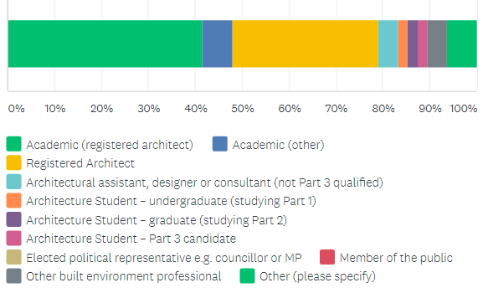
Figure 2.1: how respondents categorised themselves

  - We also asked respondents to complete some additional questions to help us collect some demographic data.
  - The majority of respondents (54%) were male, and just under a third were female. The remaining respondents chose not to identify their gender. The same proportion (6 respondents, 13%) chose not to state their ethnic group. Of those who did state their ethic group, the majority (almost 80%) were White. Whilst we received responses from across all nations and regions of the UK, the most common place of residence was London or the South East (45%).
  - Figure 2.2 shows how the respondents identified their gender, and Figure 2.3 shows how the ethnic group to which they said they belonged. Figure 2.4 shows where the respondents said they were based.

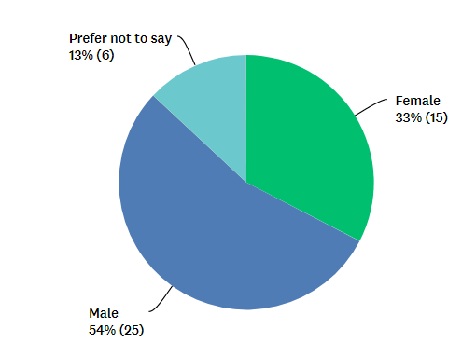
Figure 2.2: how respondents identified their gender

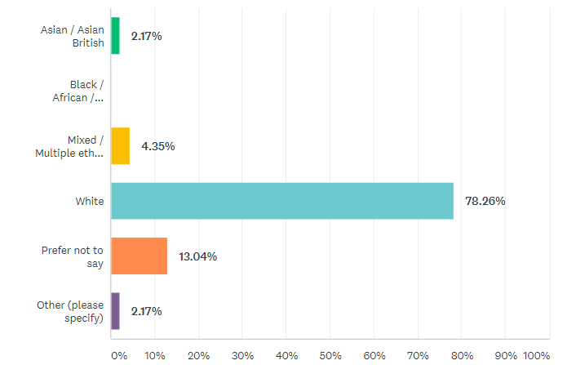

Figure 2.3: how respondents categorised their ethnic group

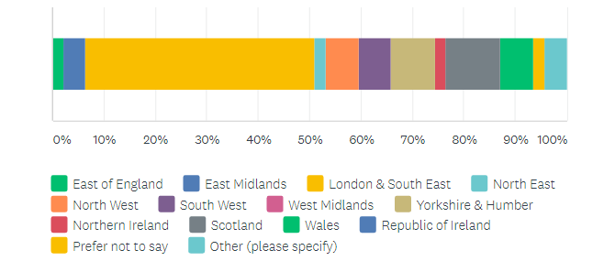
Figure 2.4: where respondents said they were based

Chapter Three: What the respondents said

Introduction

  - In our consultation we asked respondents about the clarity of each guidance document, and their views on our proposals for introducing the guidance and monitoring its application by institutions.
  - Below we summarise the range of views and recurring themes from the responses.
  - Some respondents used the open questions as an opportunity to welcome the intent of the guidance. We received positive feedback about both the need for the guidance, and the opportunity to help shape it, as provided by the consultation exercise.
We, as a group of students at Newcastle University, welcome the invitation to help influence future guidance. We will be commenting on the sustainability guidance only but welcome changes to the fire and safety guidance so that we can design safer and more sustainable buildings.”
Newcastle Students Climate Action Network

“We welcome the approach of providing interim guidance before the prescription criteria are revised - this is urgently needed.”
Architects Declare UK

  - We asked how clear each document was, on a scale of 1 (very clear) to 5 (not at all clear). Figure 3.1 below shows how all 48 respondents answered.

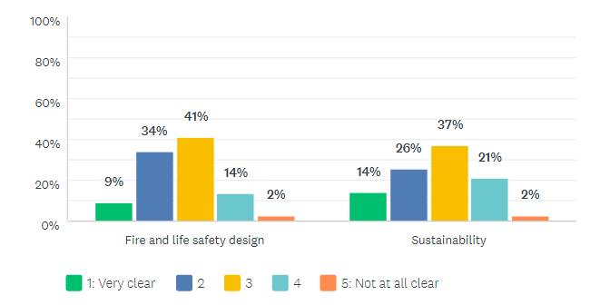
Figure 3.1: how respondents rated the clarity of each guidance document

Clarity of the Fire and life safety design guidance
  - Forty-three per cent of respondents thought the Fire and life safety design guidance was clear (ranking it at either a 1 or 2), and 16% thought it wasn’t clear (ranking it 4 or 5).
  - Whilst we received general feedback that the guidance was ambiguous, we received very few suggestions on how to improve it.
“Regarding fire safety design, it is deeply ambiguous what the expectations are regarding expertise vs knowledge and awareness. There is a deep misunderstanding of the role and responsibilities of the architect implied by this draft guidance.”
The Bartlett School of Architecture, UCL

  - Two architects responding to the consultation suggested that the guidance should refer to specific standards and regulations, by naming those that are relevant and should be covered as part of an architect’s education. It was suggested that the guidance refer to standards that have been developed in other parts of the built environment sector. It was also suggested that more attention could be paid to the need to understand collaboration and consultation when considering fire safety design.

Clarity of the Sustainability guidance
  - Forty per cent of respondents thought the Sustainability guidance was clear (ranking it at either a 1 or 2), and 23% thought it wasn’t clear (ranking it 4 or 5). Climate groups were less likely to agree the Sustainability guidance was clear, with three out of the four groups stating that it was not clear.
  - The views respondents shared about how to improve the Sustainability guidance tended to fall within following areas, which we go on to explain in more detail:
- Sustainability is a broad requirement that should be applied to all aspects of buildings and their design
- Sustainability requires a more fundamental change in the approach to education
- The guidance should be more specific about the requirements and should go so far as to set targets for the skills and understanding of architects
  - Many groups raised the importance of the guidance but suggested that further action needed to be taken. Some respondents suggested that whilst the guidance was useful, its application of sustainability was too narrow. These respondents urged ARB to take a broader approach and used the guidance to make clear that sustainability could not be limited to specific aspects of design or knowledge such as building physics and construction technologies.
“It is critical that Sustainability is not restricted to building physics and construction technologies, it must involve a fundamental change in focus for architectural education.”
Architects Declare UK and Architects Climate Action Network

“We need to question the emphasis and weight given to different strands of sustainability - only a limited theme is explored in depth and emphasised in the current guidance, the technical perspective.”
Eva Sopeoglou, Academic (registered architect)

  - The notion that sustainability should be applied broadly to all aspects of building design was often linked to a further point by respondents, namely that a major shift in the notion of sustainability is needed throughout education, and indeed in society at large. These respondents suggested that the urgency of the climate crisis demands an entirely new approach to be embedded throughout architectural education and beyond.
“It is critical that Sustainability is not restricted to building physics and construction technologies, it must involve a fundamental change in focus for architectural education as a whole. Currently, the technical aspects of architectural education carries the most, if not all, the responsibility of addressing sustainability. However, sustainability needs to be embedded within the entire curriculum, as broadly as possible, lest it is seen as a mere checkbox amongst other criteria.”
SSoA Students for Climate Action

“We are happy that there is a substantial range of key themes and topics addressed in the sustainability guidance. We also believe that the guidance can work alongside and enhance current professional criteria. Our primary concern is that the guidance does not convey the urgency of the climate and ecological emergency enough. We believe that radical change is needed now, and our education needs to be similarly urgent, highly critical, and towards significant cultural transformation.”
Newcastle Students Climate Action Network

“Education should be stretching understanding and incorporating the most cutting edge thought leadership and technologies now, or it will soon become outdated. We would urge there to be more ambition in the education guidance in particular, to foster the necessary transformation in our profession and in the construction industry at large.”
Architects Declare UK

“It is very good that ARB is addressing sustainability in education. A complete culture change is needed in our industry to meet the climate and ecological emergency, and I feel greater ambition and cultural change needs to be reflected in your guidance.”
Registered Architect

  - The scale of change necessary is so stark for some respondents, that they suggested the language we use to talk about sustainability also needs to be addressed.
“We would encourage the ARB towards adoption of 'Regenerative' terminology as opposed to sustainability - where sustainability is extending the status quo, or not net bad, and regenerative is about creating positive impacts beyond net zero/net neutral.”
Architects Declare UK

  - We also received suggestions that the guidance should be more specific. A range of points were made about this, including:
- the need for the status of the guidance to be clarified;
- suggestion that the guidance should address how institutions should go about teaching sustainability – specifying the need for a more practical approach on some aspects of sustainability, for example site visits;
- the suggestion that specific legislation and standards should be explicitly be noted;
- the request that the guidance be aligned more specifically with Parts 1, 2 and 3 of architectural education;
- the recommendation that targets should be set for skills that should be taught.

“The only effective method of ensuring all educational establishments equally addressed these guidance items would be if there were standardised tests... Students and professionals could all be tested on elements required to evidence they have met these criteria.”
Jonathan Pilbeam, Registered Architect

“The guidance must also set clear targets to demonstrate net zero carbon design competencies at GA2 and PCs, to ensure that necessary skills are obtained and not just knowledge.”
SSoA Students for Climate Action

“As a term on its own sustainability is too broad. Guidance must clarify what form or forms of sustainability are being proposed; environmental, economic, material, and/or cultural.”
Bob Sheil, Academic (registered architect)

Implementation
  - Given the urgency of the issues within this guidance, we stated our intention to begin incorporating it into our prescription process from September 2021. We asked respondents whether they agreed with this approach.
  - The majority (69%) of respondents agreed that we should begin incorporating the guidance into our prescription process from September 2021.
  - Most architects who responded (73%) agreed that the guidance could begin to be incorporated on our timelines.
  - Academics were less likely to agree. Of the 27% of respondents who did not agree with the proposed timeline, the majority (77%) were academics. Figure 3.1 below shows which stakeholders disagreed with our timeline.

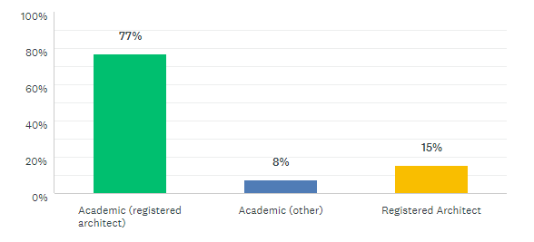
Figure 3.1: a breakdown of the 27% of respondents who did not agree with our proposed implementation date of September 2021.

  - As a stakeholder group, academics were split as to whether the guidance could be implemented by September 2021. Roughly half agreed that the implementation date (52%) and the other half did not agree (48%).
  - Of the respondents who disagreed, approximately 50% suggested the changes could reasonably be implemented by 2022/23 academic year. The remaining 50% did not suggest an alternative.
  - Respondents raised a number of concerns, including resources constraints, and potential student dissatisfaction and staff departures.
  - Academics told us that while the guidance should be implemented as soon as possible, the planning, resourcing and Quality Assurance required to introduce or change modules mean that a realistic timeframe would be 12-18 months.
“The expertise needs to be created first. especially in fire engineering. there simply are not enough existing experts to teach the subject in all 50 schools.”
Bob Sheil, Academic (registered architect)
“A transformation implied by the guidance takes a lot longer. The typical UCL module change period is 18 months.”
The Bartlett School of Architecture, UCL

  - We proposed that we check progress of implementation through our annual monitoring process, and asked respondents whether they had any views on this proposal.
  - The majority (85%) of respondents agreed with our proposal.
  - Some respondents commented on the limitations of the annual monitoring system, highlighting that it will merely check that the guidance will be covered. The view expressed by some respondents was that this would approach would not provide any feedback on the quality of delivery that could be used to improve future teaching, or consider the quality of outcomes for students.
“We question if there is enough existing knowledge amongst educators to implement this new guidance in a comprehensive way in the proposed time frame. We would like to see up-skilling of the generation that is currently responsible for educating to ensure that an adequate level of competency is being taught.”
WestCAN

Chapter Four: ARB’s response

Introduction

  - Below we summarise our response to the main themes raised by respondents, as reported in the previous chapter. Where we have decided not to take further action, we explain the rationale.

Clarity of the Fire and life safety design guidance
  - Whilst we received some useful suggestions as to specific standards that should be referenced, point FB2 in the guidance already refers to the need for the curriculum to cover key pieces of legislation and regulations. We do not intend to list specific examples, nor to go into further detail to name the standards or applied documents beneath them. It is the institution’s responsibility to make sure they teach students and candidates about the most up to date legislation and regulation. If we were to name them in this guidance, there is a risk it would need to be republished regularly as specific documents and standards are changed or updated over time.
  - We will strengthen the wording of point FB4 in the guidance to include collaboration and consultation as part of the architect’s role in the design team.

Clarity of the Sustainability guidance
  - Whilst sections C and D of the guidance refer to building physics and construction technologies, sections A and B of the guidance serve to widen the context in which sustainability must be considered. Sections A and B cover, for example, the need for architects to learn about natural habitats, infrastructure, and the relationships between buildings. We therefore believe the scope already goes beyond building physics and construction technologies, and we are not proposing to amend the guidance to emphasise this any further.
  - We agree with those respondents who state that guidance on sustainability will not in itself solve the climate crisis, and who have urged us to do more. We are currently reviewing the initial education and training that architects undergo, and the way that we recognise qualifications so that architects can join the UK register.
  - This review has the potential to deliver on points made by respondents to this consultation. First, moving away from a more prescriptive set of input measures to instead focus on the outcomes means that qualifications, will focus on the skills people gain rather than set the material they should be taught. This is similar to the point some respondents made about targets. Second, it opens the opportunity for a more fundamental approach to sustainability throughout education and training. The review of our prescription criteria already underway will enable a more fundamental review of sustainability in initial education and training of architects. We are fully committed to wide ranging engagement and consultation with the sector as part of this fundamental review. This review would also be an opportunity to revisit the language and terminology that is used.
  - We will be more explicit about the status of this guidance. When we introduce it, we will write to institutions that deliver ARB-recognised qualifications and we will set out that, as supplementary guidance to the ARB General Criteria, it is a formal part of the prescription process.
  - We have not made recommendation about how the guidance is taught, as we believe the regulator should set a flexible approach and the format of the teaching is best determined by academics.
  - Whilst we received some useful suggestions as to specific standards that should be referenced, point SA4 in the guidance already refers to the need for the curriculum to cover key legislation, regulations, policies and guidance relating to the built environment on climate change and the ecological crisis. We are not proposing to name specific legislation, policies, guidance or standards for the same reasons as we outline above, regarding the Fire and life safety guidance.

Implementation
  - We have listened to the concerns, especially from institutions, as to the timing of implementation. We will give institutions time to plan how they will develop and deliver any additional course content required as a result of the guidance. Our expectation is that there is a commitment to do so within a reasonable time and that progress can be demonstrated during the annual review process. We understand that institutions will all have different distances to travel to demonstrate compliance.
  - We will monitor the progress of compliance through ARB’s existing Annual Monitoring process, and where institutions are applying for a renewal of their existing qualification. Applications for the prescription of a new qualification will be required to include a plan for how that qualification will cover the points in the guidance.
  - We want to work with institutions and support them in making any necessary changes to their course content. We will, however, retain the power to take regulatory action in relation to the qualifications of those institutions who are unwilling or unable to take meaningful steps towards compliance.

Chapter Five: Conclusion

  - On the basis of this report on the consultation, the ARB Board has considered the changes to the guidance, implementation and monitoring as set out above. The guidance has been approved for publication by the Board, and we are therefore publishing it alongside advice on implementation.
  - The guidance forms part of a thorough review ARB is undertaking to consider the initial education and training that architects undergo, and the way that we recognise qualifications so that architects can join the UK register. This review will continue through 2021; more information can be found here.
[This document is in draft form and this conclusion will be edited following the Board discussion on the consultation and the guidance.]

Annex A: List of respondents

- Alasdair Dixon, Registered Architect
- Andrea White, Built environment professional
- Architects Declare UK
- Architects Climate Action Network
- The Bartlett School of Architecture, UCL
- David Stronge, Registered Architect on behalf of Peabody
- Eva Sopeoglou, Academic (registered architect)
- Francesco Sacconi, Registered Architect
- Gavin Richards, Academic (other), on behalf of Nottingham Trent University
- Gokay Deveci, Academic (registered architect)
- Harry Charrington, Academic (registered architect) on behalf of University of Westminster
- James Burch, Academic (registered architect) on behalf of UWE, Bristol
- Jermaine Clarke, Registered Architect
- Jonathan Pilbeam, Registered Architect
- Martina Murphy, Academic (registered architect)
- Maxwell Kemplen, Architecture Student – undergraduate (studying Part 1),
- Paul Barham, Registered Architect,
- Robert Brown, Academic (registered architect), on behalf of University of Plymouth (Architecture)
- SCHOSA
- SSoA Students for Climate Action
- Tabitha Binding, Built environment professional
- Vincent MacDonald, Architecture Student – graduate (studying Part 2), on behalf of Newcastle Students Climate Action Network
- WestCAN

- Two academics
- 12 architect academics – three of which responded on behalf of institutions that did not agree to be identified
- Two Architectural assistant, designer or consultants (not Part 3 qualified)
- Nine registered architects

For example, we received 20 responses from academics who were registered architects – of these 12 responded as individuals and eight responded on behalf of organisations. When we say ‘academics who were registered architects’ in the rest of this report, we will be referring to the full 20 respondents.

